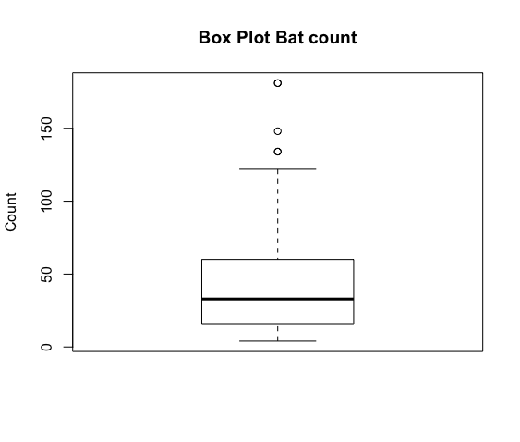
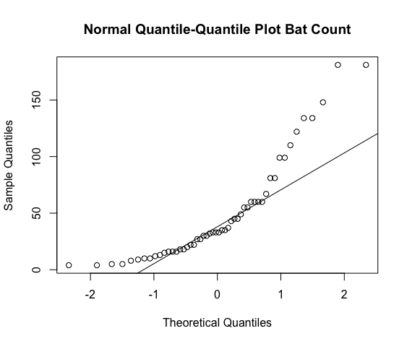
Histogram: This histogram is right skewed and has a mean of 49.30769.
Box plot: This box plot has an IQR of 44 and a median of 33, with 3 outliers: [181, 134, 148].
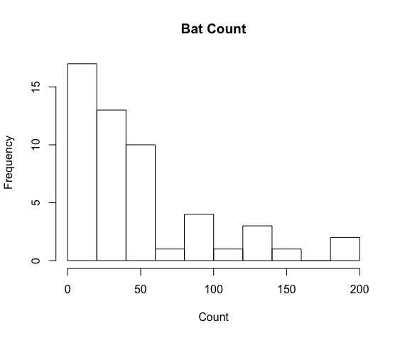
Normal Quantile-Quantile: This plot is right skewed.

